**Results:**

**Part 1 : Digit Recognition**

**Overview:**   
I have used Bernoulli Naive Bayes classifier with different alpha values for this part of assignment. Analysis is done based on the varying values of the alpha parameter. For this dataset, the difference wasn’t significant. Following are the few outputs based on variables:  
  
For digit recognition approximately 77.8% of the predictions came valid.

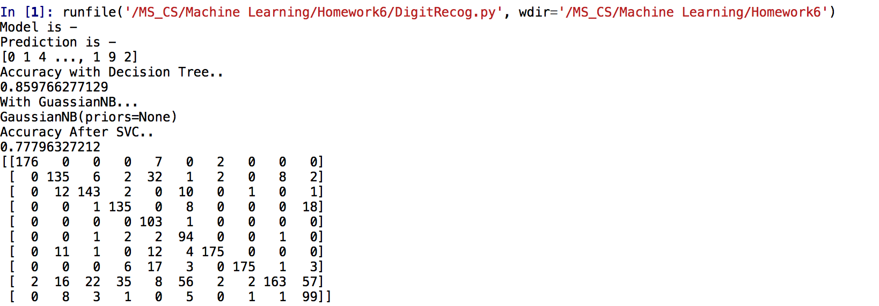

ii) Following is the screenshot showing the Multinomial naive bayes and Bernoulli naive bayes. The predictions are approximately 88.9% accurate for multinomial naive bayes with alpha parameter taken as 0.0001.

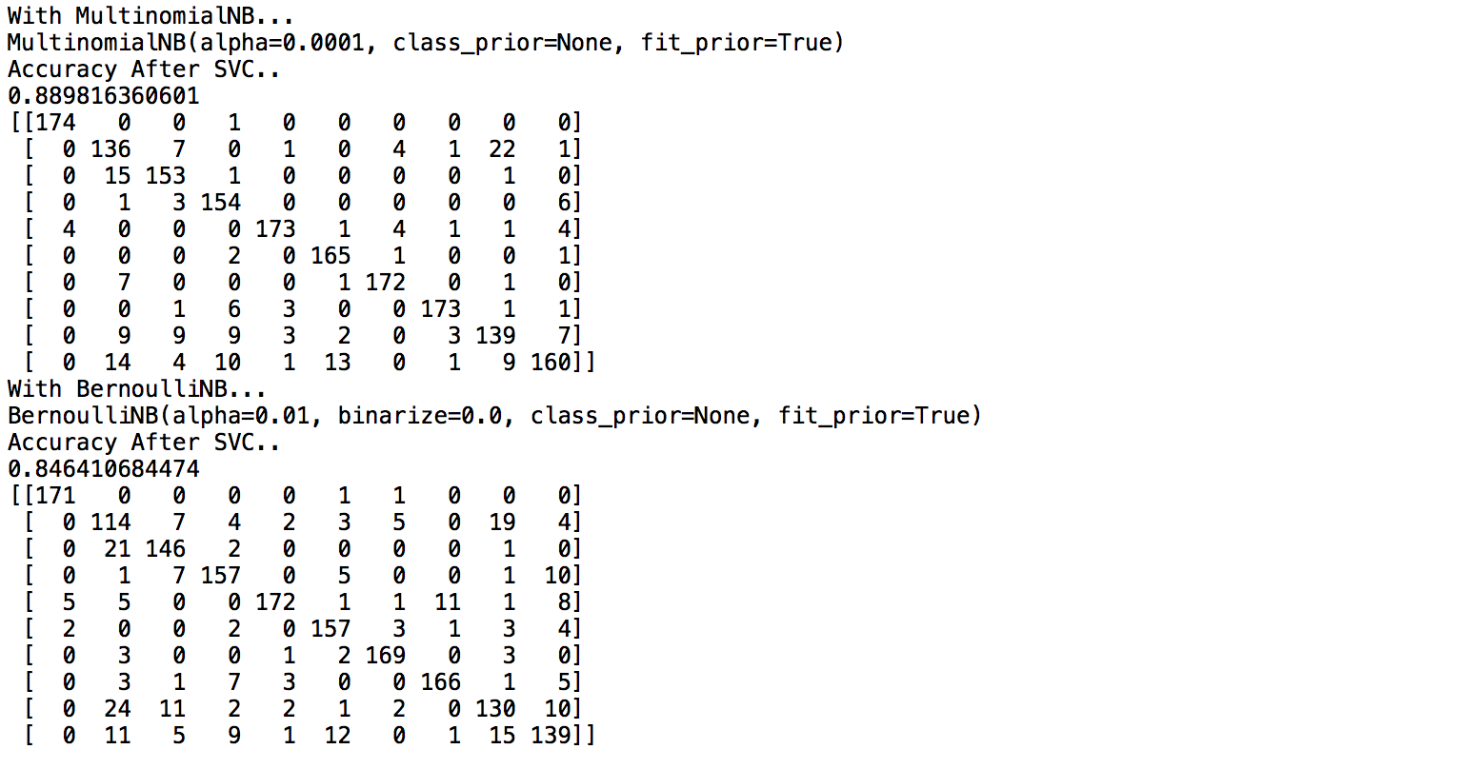

**For digit recognition multinomial naive bayes seems to be an effective model which produces almost 88.9% of the accuracy.**

**Part 2: Amazon Data Set:**

**Overview:**

I have used Bernoulli Naive Bayes classifier with different alpha values for this part of assignment. Analysis is done based on the varying values of the alpha parameter. For this dataset, the difference wasn’t significant. Following are the few outputs based on variables:

i) Initially putting the alpha value as 0.05, the accuracy was highest for the Multinomial Naive Bayes. It is then followed by Bernoulli naive bayes and Gaussian Naive Bayes. About 63.5% of the prediction accuracy when multinomial naive bayes is applied on the dataset keeping the alpha parameter as 0.05.

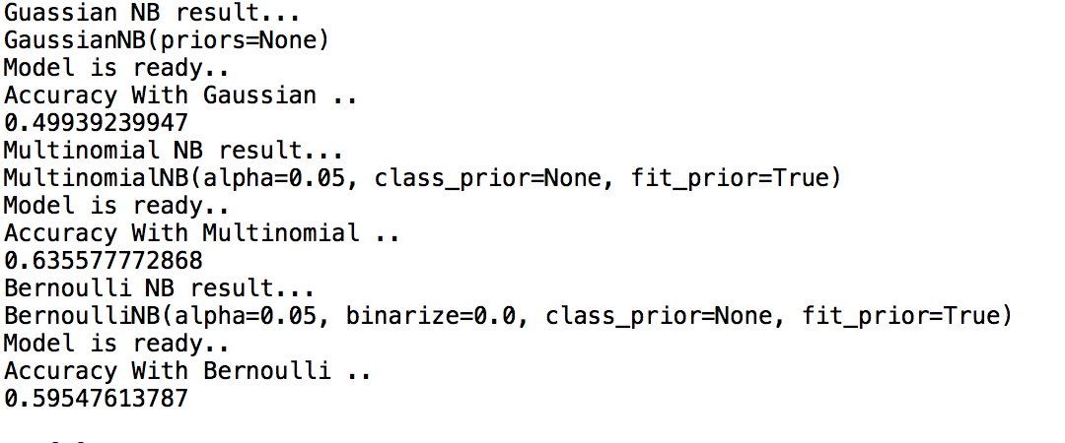

ii) Further reducing the alpha value by a factor of 10 to 0.005, the accuracy was again highest for the Multinomial Naive Bayes. It is then followed by Bernoulli naive bayes and Gaussian Naive Bayes. About 63.5% of the prediction accuracy when multinomial naive bayes is applied on the dataset keeping the alpha parameter as 0.005. Again the change in alpha parameter doesn’t contributes much to the accuracy.

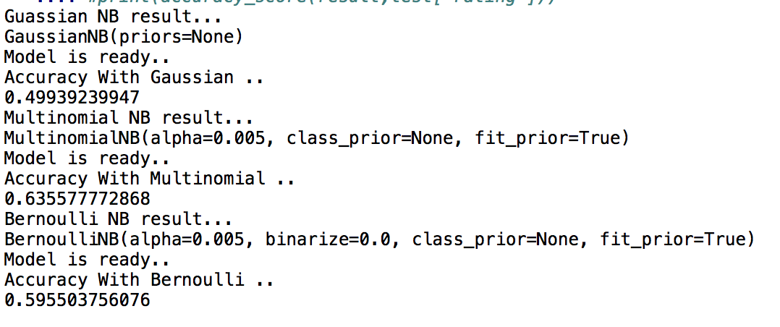

iii) Now, enhancing the alpha value to 0.5, the accuracy was again highest for the Multinomial Naive Bayes. It is then followed by Bernoulli naive bayes and Gaussian Naive Bayes. About 63.5% of the prediction accuracy when multinomial naive bayes is applied on the dataset keeping the alpha parameter as 0.5. Again the change in alpha parameter doesn’t contributes much to the accuracy but we can say that the accuracy has been improved by a very tiny factor.

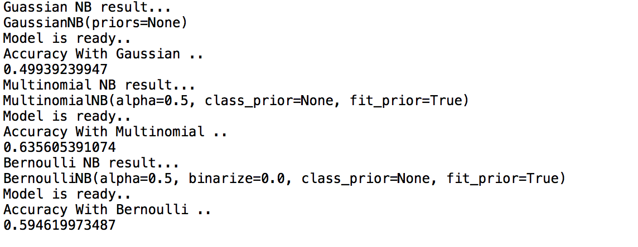iv) If we put the alpha value as 1.0, the accuracy was again highest for the Multinomial Naive Bayes. It is then followed by Bernoulli naive bayes and Gaussian Naive Bayes. About 63.5% of the prediction accuracy when multinomial naive bayes is applied on the dataset keeping the alpha parameter as 1.0. 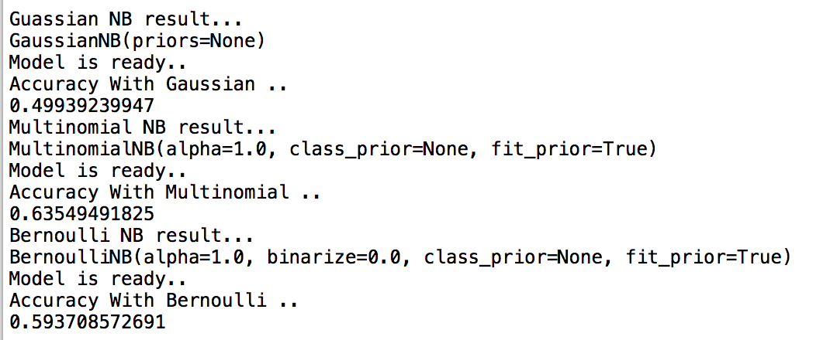

**However the prediction accuracy percentage is not totally promising using the naive bayes model for the amazon data set, the Multinomial naive bayes seems to produce the best results compared to Bernoulli Naive Bayes and Gaussian Naive Bayes.**